# **CORPORATE TRAVEL MANAGEMENT SYSTEM**



**Group 12**

**Vyshnavi Daka**

**Shreeja Dasari**

**Lalit Lochan Muppalla**

**Hemanth Kumar Rallapalli**

**Nirant Zanzote**

**INDEX**

|  |  |
| --- | --- |
| **What is Corporate Travel Management?** | **3** |
| **Why is Corporate Travel Management Important?** | **3** |
| **Objective** | **3** |
| **Our Proposed System** | **3** |
| **ER Diagram** | **5** |
| **Tables Description** | **6** |
| **Technical Details of Employee Travel Management Database** | |
| * **Creating Tables** | **6** |
| **Implementation & Strategy** | |
| * **Stored Procedures** | **10** |
| * **Triggers** | **11** |
| * **Stored Functions** | **12** |
| * **Queries** | **13** |
| * **Views** | **14** |
| * **Conclusion and Future Scope of the project** | **15** |
| * **Contribution of Each Team Member** | **16** |

**What is Corporate Travel Management?**

Corporate Travel Management is a process of managing a company's strategic approach to travel. It is the structure that a company has put in place to oversee and facilitate the business travel which helps in booking, tracking and analysing the business travel. It offers solutions for a firm's travel needs and fully controls the requirements for business travel. Therefore, at the corporate level, travel management is regarded as a holistic travel plan.

**Why is Corporate Travel Management Important?**

Corporate travel management is very important as it plays a crucial role in getting most out of a company’s travel budget by ensuring that a company is not overpaying a lot for transportation and accommodation. This is also important as it establishes a way on how to arrange business trips by the employees and ensures that all the travel expenses incurred or allocated is in the best interests of the company. A good corporate travel management program also ensures the traveller safety.

**Corporate Travel Management using RDBMS**

**Objective:**

The aim is to design a model that can be used for business travel management. This aids a range of services to corporate entities that can track and manage vast modules of function concerning employees' business travels. This approach enables reliable access and synchronised information across the company. The offered system is prepared to be more efficient than the traditional systems. It gathers all jobs now carried out manually, such as storing transactions and reports. The system is an entirely computer-based application, and thousands of records can be searched and displayed without taking significant time.

A business has an immense number of daily operations. It is very challenging to keep records of employees and their travel information. This is solved using RDBMS: Relational Database Management System to create a database consisting of entities and their relationship with stored procedures and functions representing various services of their respective business workflows. For example, when booking a flight for a business purpose for an employee, the details would be used from the employee repository. After booking, provide a copy to them and keep this information in the database for financial purposes.

The Corporate Travel Management System using the database management system is robust as it meets the business norms, as normalisation is applied on all the tables. This system allows business users to fetch any data of any company function for reporting or other purposes. As data is saved in a structured manner, it can be used and comply in the future for the business.

**Our Proposed System:**

The proposed model is designed to provide a one-stop platform for automating the travel management of the companies. This model is targeted for those users who include Corporate Travel Managers and the people from Finance or Administrative Services Department.

This model covers two major workflows of business travel of corporate employees.

1. Assigning the raised travel requests to the concerned managers and processing of the requests.

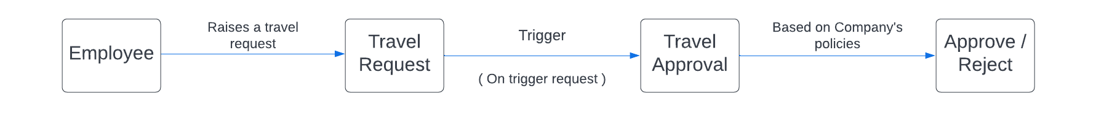

1. To help manage the travel and expenses of employees on their business trips.

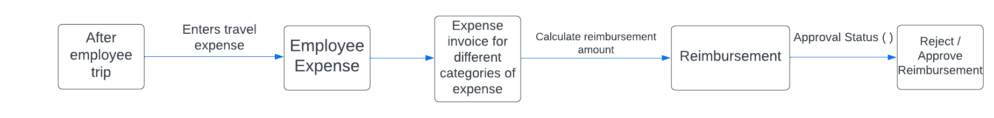

Following is included in the proposed system database:

* Employees can raise travel requests and are allowed to book their trips according their preferences.
* The approval workflow of the company so as to get the necessary approval from the concerned managers or team leads based on the business travel purpose and preferences.
* The company policy which includes the details such as maximum cost of airfare, flight class allowed, hotel star rating, maximum cost per hotel per night.
* Booking information done by the employees. This information includes the departure destination, flight booking and the hotel booking.
* Travel expenses reporting information so as to track the expenses incurred on each trip.
* Reimbursement process as per the company travel policy and approval workflow of the company.

**ER Diagram:**

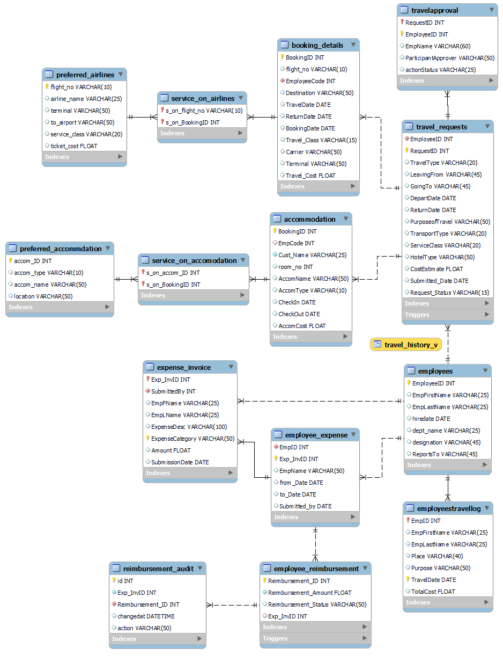

**Tables Description:**

|  |  |  |
| --- | --- | --- |
| **Table Name** | **Primary Key** | **Foreign Key** |
| Employees | EmployeeID |  |
| Travel_Requests | RequestID | EmployeeID |
| TravelApproval | RequestID,EmployeeID | RequestID |
| preferred_airlines | flight_no |  |
| Booking_details | BookingID | EmployeeID |
| service_on_airlines | s_on_flight_no | BookingID, flight_no |
| preferred_accommdation | accom_ID |  |
| Accommodation | BookingID |  |
| service_on_accomodation | s_on_accom_ID | accom_ID, BookingID |
| EmployeesTravelLog | EmpID,TravelDate | EmpID |
| Employee_Expense | Exp_InvID | EmpID |
| Expense_Invoice | Exp_InvID,ExpenseCategory | SubmittedBy, Exp_InvID |
| Employee_Reimbursement | Reimbursement_ID | Exp_InvID |
| reimbursement_audit |  | Reimbursement_ID |

**TECHNICAL DETAILS OF EMPLOYEE TRAVEL MANAGEMENT DATABASE**

**Creating tables:**

Following are the tables created for the proposed system:

**Employees:**

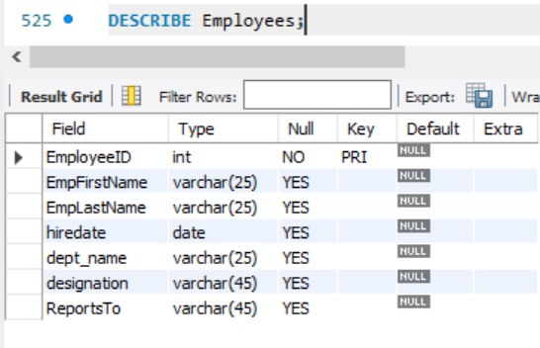

**Travel_Requests:**

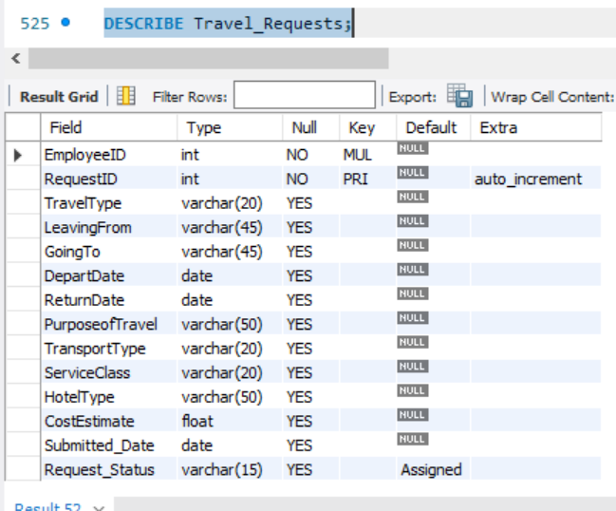

**TravelApproval:**

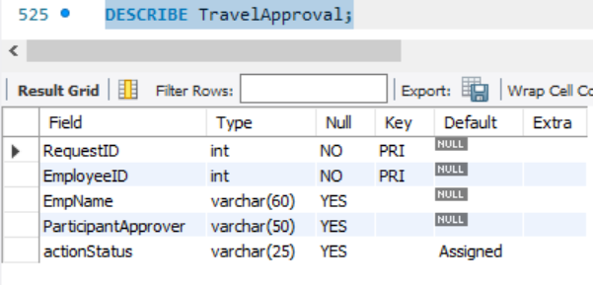

**preferred_airlines:**

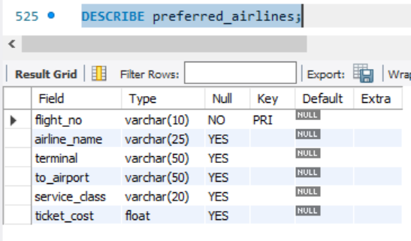

**Booking_Details:**

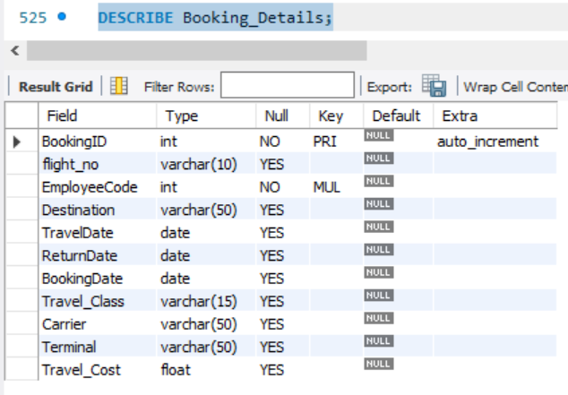

**Preferred_Accommodation:**

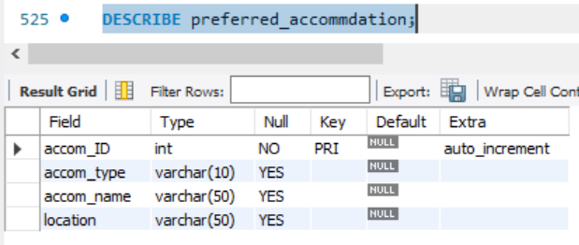

**Accommodation:**

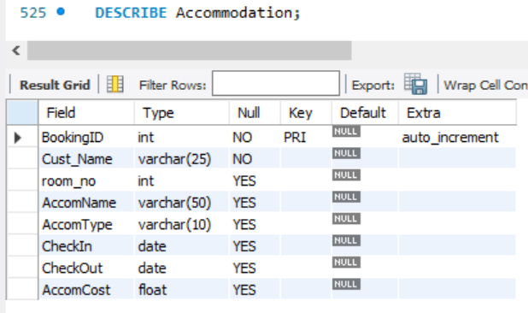

**Service_on_airlines:**

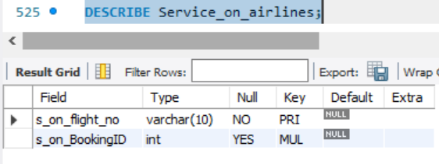

**Service_on_accommodation:**

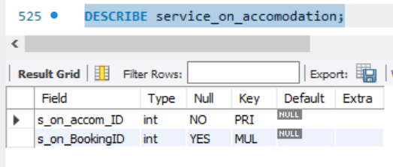

**Employee_Expense:**

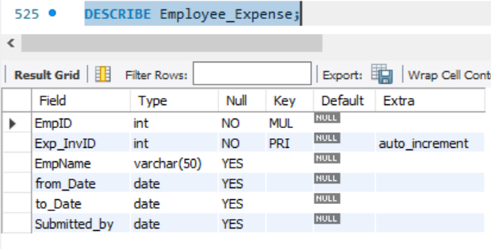

**Expense_Invoice:**

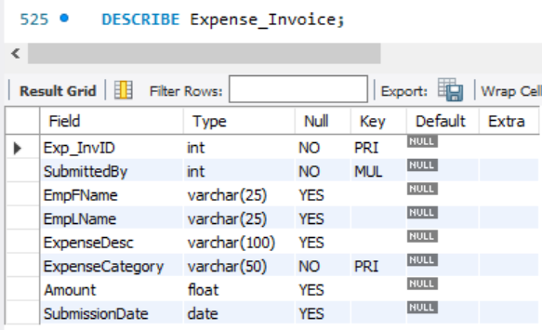

**Employee_Reimbursement:**

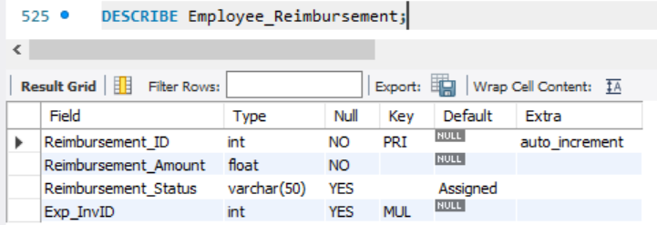

**Reimbursement_audit:**

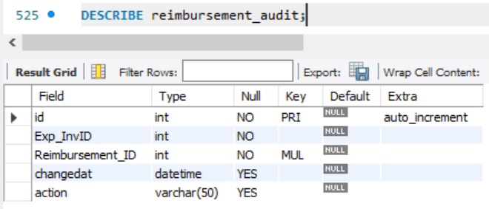

**EmployeesTravelLog:**

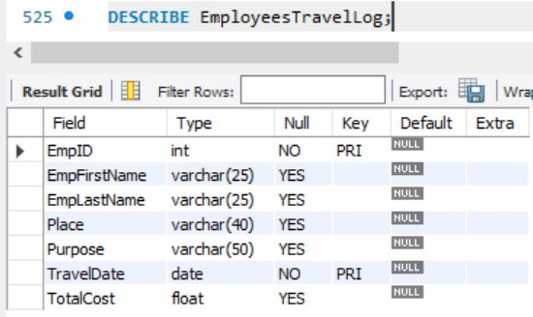

**IMPLEMENTATION & STRATEGY:**

**Stored Procedures:**

**Procedure 1: CompanyTravelPolicy**

This procedure is used to either approve or reject a travel request raised by the employee for a business trip. Generally, companies have a travel policy decision matrix based on which travel requests are approved. In our model, we simplified the policy where we took into account the duration between the date on which request is raised and the expected data of travel. If the duration is greater than 15 days, the travel request will be automatically approved and the status will be updated in both Travel_Requests and TravelApproval Tables.

Below is an example of the travel request approval:

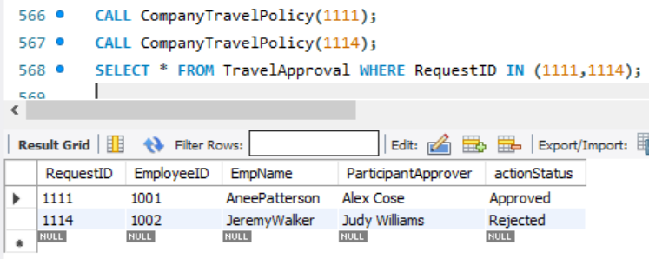

**Procedure 2: CalculateReimbursement**

This procedure is used to calculate the total reimbursement amount using the expense invoice ID by calculating the total expenses for various categories of expenses incurred during the business trip of the employee. Besides calculating the total amount, this procedure will simultaneously insert the reimbursement details of the employee into employee_reimbursement table.

Below is an example to demonstrate the procedure:

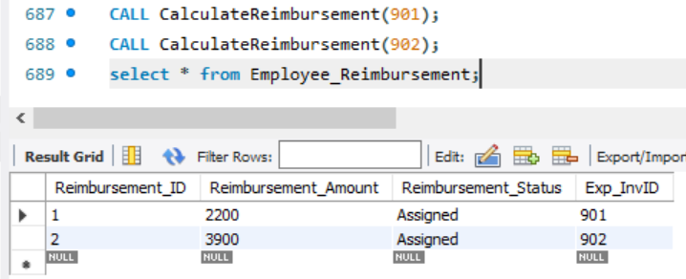

**Procedure 3: Reimbursement_Approval**

This procedure is called when the expense invoice is sent for approval by the employee to his/her reporting manager/ Admin or Finance Department. Here the procedure will check each expense category against the company travel policy budget and will reimburse the amount when the trip is with in the budget otherwise it will reject the reimbursement.

* As per the company travel policy, the transportation costs should be within $3000, Accommodation costs should be under $1000 and the Miscellaneous which includes food, cab services and other activities under $200.

Below is an example to demonstrate the procedure:

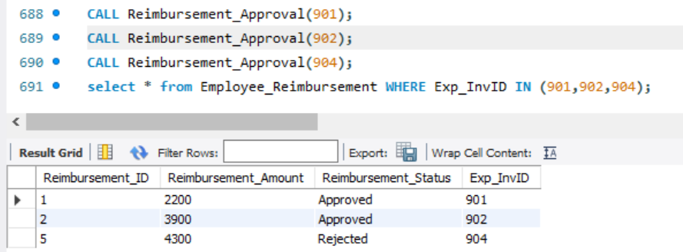

**Triggers:**

In our business model, we have two types of triggers. One is post-insert trigger and the other is post-update trigger.

**Trigger 1: travel_approval_worflow**

This trigger is a post-insert trigger on Travel_Requests table to dynamically insert values into the TravelApproval table. Once an employee raises a travel request, as soon as the request is raised, it will automatically go to the concerned reporting manager for the approval. This trigger will automatically assign the status to ‘Assigned’ in the TravelApproval table when an employee requests for a business trip.

**Trigger 2: after_reimbursement_update**

This is a post update trigger to capture changes on the reimbursement table. It will capture the approval/rejection status of the reimbursement after going through the approval workflow. When a report is needed to be generated which includes all the expense and reimbursement details of a business trip, these changes will aid in generating such report with the action status and time of approval.

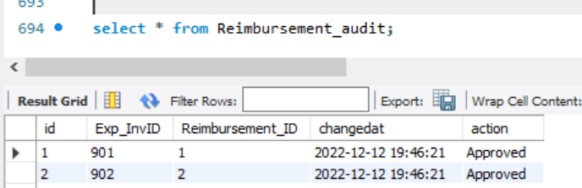

**Stored Functions:**

**Function 1: GetTotalExpenses**

For calculating the total expenses incurred for various categories like transportation, hotel, cab, food and other activities based on the expense invoice id generated by the employee.

This is done by adding the different expenses using the aggregate function SUM () and grouping by the expenses by expense invoice id.

Below is an example for the employee with expense invoice id as 904:

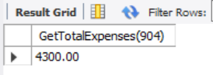

**Function 2: Frequent_Traveller**

Employees are categorized into two types: Frequent Traveller and Non-Frequent Traveller based on the number of business trips the employee has taken till date. Total travel history of all employees is stored in employeestravellog table.

In this function, the total trips an employee has taken is counted using the aggregate function COUNT (). Since the proposed model is small, the threshold value to categorize an employee as frequent traveller is kept at 3 i.e. If an employee has taken more than 3 business trips, he/she will be categorized as a frequent traveller using their employee ID.

Below is an example for those employees with employee ID 1010 and 1001:

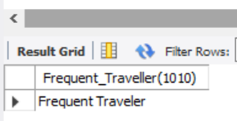

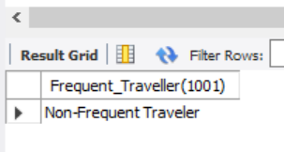

**Queries:**

**Query 1:** To find out the top 5 employees with highest expense generated and the invoice submitted dates for the same.

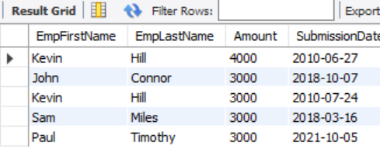

**Query 2:** To find out the employees who went on a trip with highest number of days along with the estimated and actual travel costs. We are also interested to find out only those employees trip details where the actual travel cost doesn't deviate more than $1000 from estimated costs.

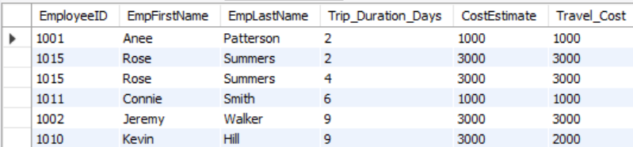

**Query 3:** To find the employees with Maximum Reimbursement clamied.

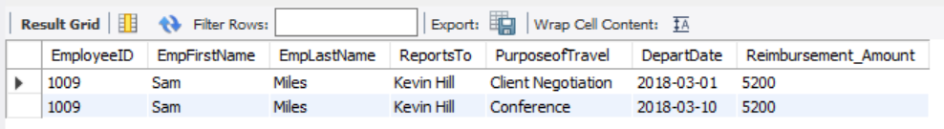

**Query 4:** To find the employee travelling location and Travel type.

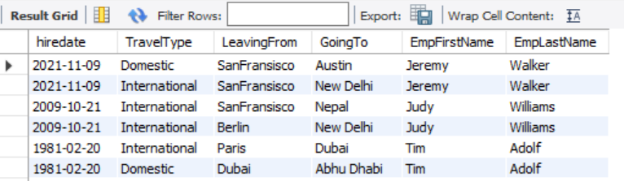

**Query 5:** To find out the employee who travelled for conference by using business class.

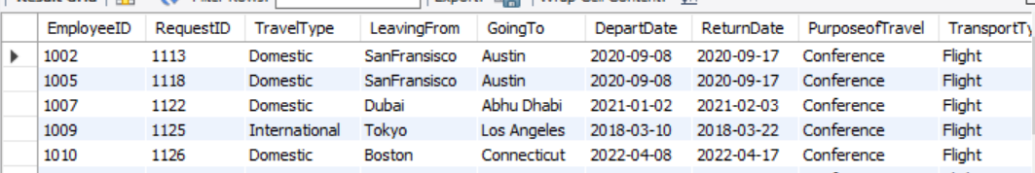

**Query 5:** To Retrieve flight_no, Destination, TravelDate, infomation of Airlines and if ticket Price is more than 3000.

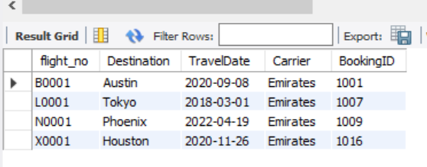

**Views:**

**View 1:** Travel_History_v view to view the entire travel log of employees from pre-trip to post-trip.

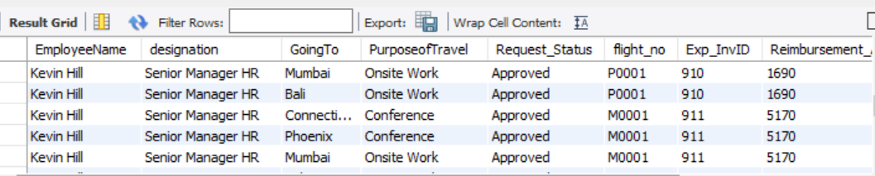

**Conclusion and Future Scope**

In conclusion, A high-quality travel management system will significantly improve the quality of your operations because it centralizes key data and decision-making around travel. We help to automate away lots of procedural tasks that previously were done by travel managers. Not only does this remove the risk of human error, but it frees up time that can be better deployed elsewhere.  
Having a good travel management system will also allow the company to get a better grasp on how their travel is impacting the business more generally. Being able to pull sophisticated reporting on travel activities is a great way to monitor business travel and ensure that it is delivering what it needs to be in line with strategic objectives.  
This helps to simplify expense report management and ensure that everything is being recorded for quality assurance purposes.  This simplification also makes a big difference in terms of remittances and reimbursements when required, not to mention the benefit of better visibility into key travel budgets.

In future scope of design, we are planning to include ground-level transport management services which includes cab and fleet services, different platforms such as taxis and ridesharing companies connected to the company, travel support information for providing support to employees which include native language support or emergency travel plans and employee tracking during the entire course of trip in order to ensure employee safety.

**Contribution of Each Team Member**

|  |  |
| --- | --- |
| **Team Member** | **Contribution** |
| Vyshnavi Daka | Tables, Procedures, Functions, Triggers, View, Report |
| Shreeja Dasari | Business Plan, Data, Procedures,Report-Conclusion |
| Hemanth Kumar Rallapalli | Queries |
| Lalith Lochan Muppalla | Queries |
| Nirant Zanzote | Business Plan, Queries, Data, PPT |